Advance Computer network PCS223
Assignment-4
Suryansh Sharma 8025320099

Q.1 Create a pool on the DHCP Server router, named “xyz” and follow all the requirements.
1. Client should use the DNS server with the IP address: 1.2.3.4
2. Client should use the network 192.168.10.0/24
3. Client should renew their IP address after every 3 hours
4. Make sure, Router does not respond to any BOOTP
5. Configure the Client so that it will obtain IP from DHCP server.
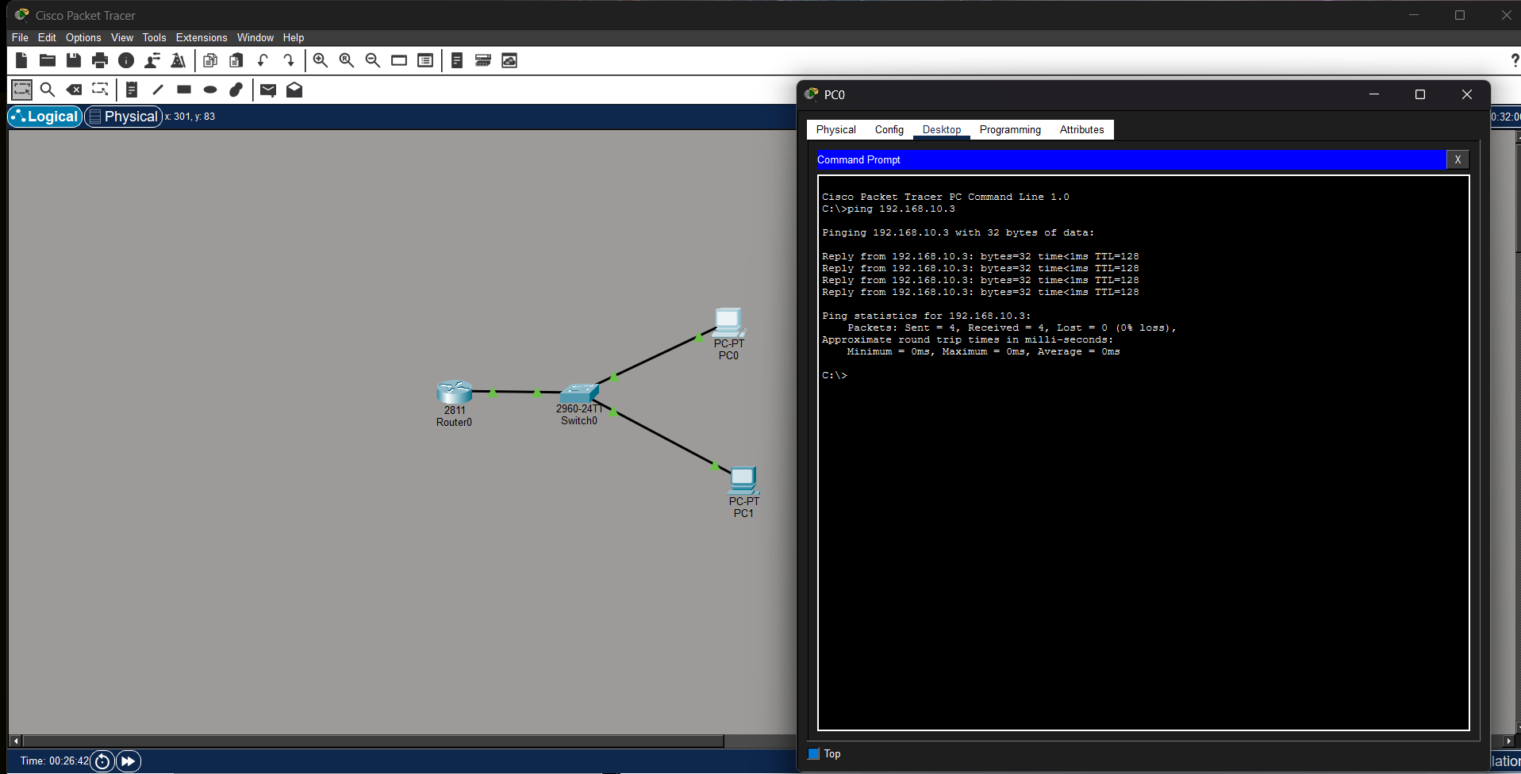

Observation:
A DHCP pool named “xyz” was configured on the router with network 192.168.10.0/24. DNS server and default gateway were assigned. Clients were configured to obtain IP addresses automatically.
Result:
Clients successfully obtained IP addresses from the DHCP server and communication was verified.

